**DEPARTMENT OF MECHANICAL ENGINEERING  
  
Subject: Fundamentals of Programming  
Home Task. 6  
Submitted by: Muhammad Maaz  
Registration number: 479510  
Semester No. 1  
Date: November 20, 2023**

**FIRST PROGRAM**

#include <iostream>

using namespace std;

int main()

{

int sum = 0;

for (int i = 1; i<=50; i++) {

int factors=0;

for (int j = 1; j<=i; j++) {

if (i%j==0) {

factors++;

}

}

if (factors == 2) {

sum += i;

}

else {

continue;

}

}

cout<<"Sum of all primary numbers from 1 to 50 is "<<sum;

}

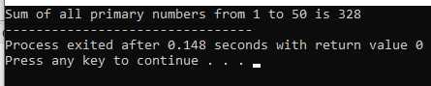

**Second Task**

#include <iostream>

using namespace std;

int main()

{

int rows;

cout<<"Enter number of rows: ";

cin>>rows;

for (int i = 1; i<=rows; i++) {

for (int j = 1; j<=i; j++) {

cout<<" "<<j;

}

cout<<endl;

}

return 0;

}

**Third Task**

#include <iostream>

using namespace std;

int main()

{

int rows;

cout<<"Enter number of rows: ";

cin>>rows;

cout<<" 1\n";

for (int i = 1; i<=rows*2-1; i++) {

if (i%2==1){

continue;

}

for (int j = 1; j<=i; j++) {

cout<<" "<<i;

}

cout<<endl;

}

}

